**PCF Architecture**

Let us take a look at the PCF architecture:

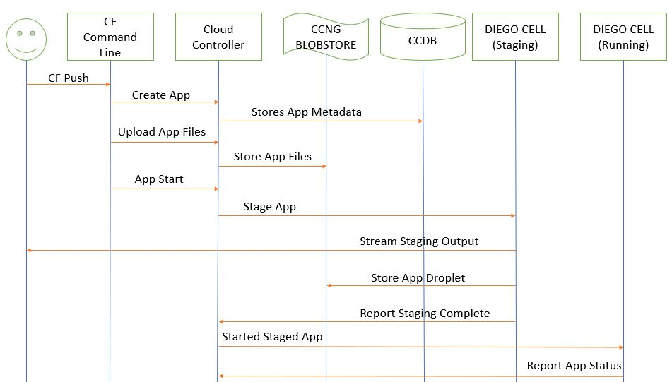

"Diego is a self-healing container management system that attempts to keep the correct number of instances running in Diego Cells to avoid network failures and crashes. Diego schedules and runs Tasks and Long-Running Processes (LRP)." - [Cloud Foundry](https://docs.cloudfoundry.org/concepts/diego/diego-architecture.html)

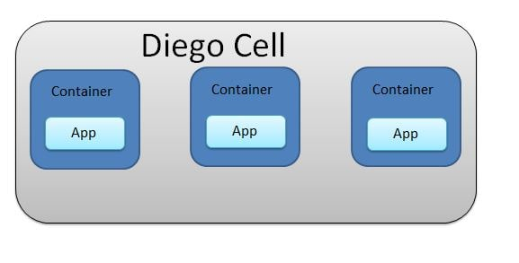

Here is a table displaying the Roles and the associated permissions for PCF.

|  |  |
| --- | --- |
| **Role** | **Permissions** |
| Admin | An admin user has permissions on all Orgs and Spaces |
| Admin Read-Only | This role has read-only access to all Cloud Controller API resources. |
| Global Auditor | This role has read-only access to all Cloud Controller API resources except  for secrets such as environment variables. |
| Org Managers | Managers or other users who need to administer the Org. |
| Org Auditors | Can view but cannot edit user information and Org quota usage information. |
| Org Billing Managers | Can create and manage billing account and payment information. |
| Org Users | Can view the list of other Org users and their roles. When an Org Manager gives  a person an Org or Space role, that person automatically receives  Org User status in that Org. |
| Space Managers | Managers or other users who administer a Space within an Org. |
| Space Developers | Application developers or other users who manage applications  and services in a Space. |
| Space Auditors | Can view but cannot edit the Space. |